Feed Update Procedure

This document describes feed update procedure for feed firmware 5.4, that can be done in Hat Creek Radio Observatory. The “feed laptop” has a MPLAB 5.25 software installed (mplab_ide).

# Downloading latest code

Make sure that the code is in the latest version. On the “feed laptop” the repository resides in

|  |
| --- |
| */home/sonata/antonio-feed-controller-board* |

directory. If it’s not there or with new system installment, download the repository from the github:

|  |
| --- |
| git clone https://github.com/SETIatHCRO/antonio-feed-controller-board.git |

Make sure that both “bootloader” and “feed_control” projects are open. The project tab should look as below (note that **Bold** selection may differ)

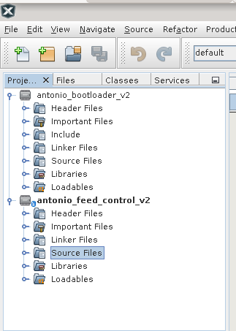

If any of those is missing. Press “File->Open Project …” and select the missing project. The available projects are displayed with “chipset” icon rather than standard directory icon

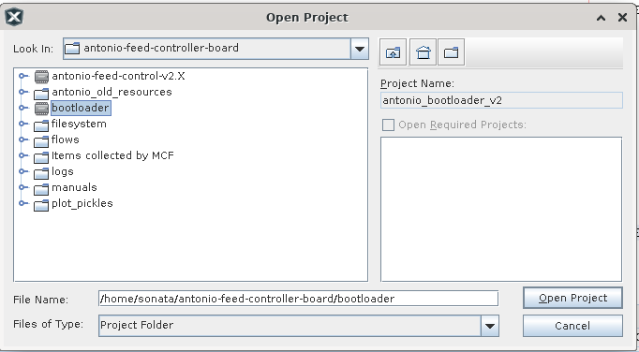

# Compile code and prepare image

Since the feed_controller hex file is also copied to the feed “sd” flash, make sure that it’s properly compiled. Right-Click on antonio_feed_control _v2 name and make it the main project

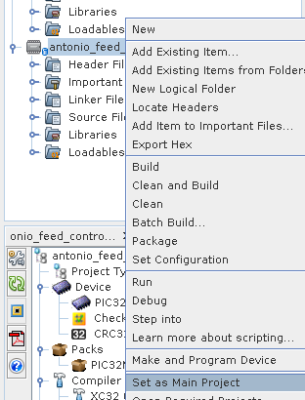

Compile the project. Press “SHIFT + F11” or go to “Production->Clean and Build Project”. The bottom window should look like this:

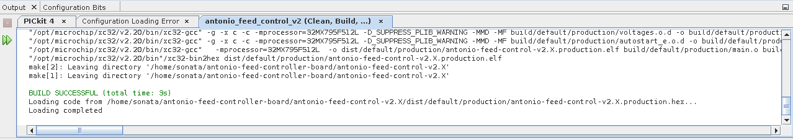

When it’s complete, open the terminal in the “*filesystem*” subdirectory and call bash script

|  |
| --- |
| ./createimage.sh |

The script may ask for a root password (required to mount loop device). The script should finish with the line “filesystem image created” You may want to move the created image (antoniofsimage) to the main directory.

# Compile bootloader

At this point you may want to compile the bootloader project as well. Make sure to set the bootloader as a main program (picture above). Then press “SHIFT+F11” or “Production->Clean and Build Project”. The output of compiler should be as follows (picture below)

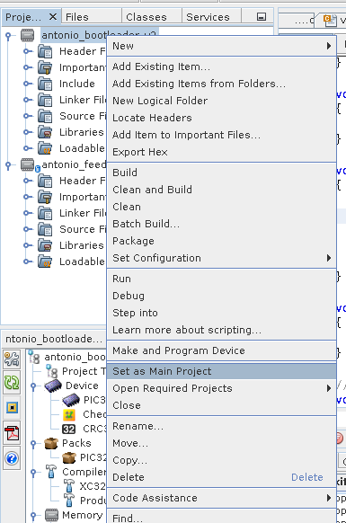

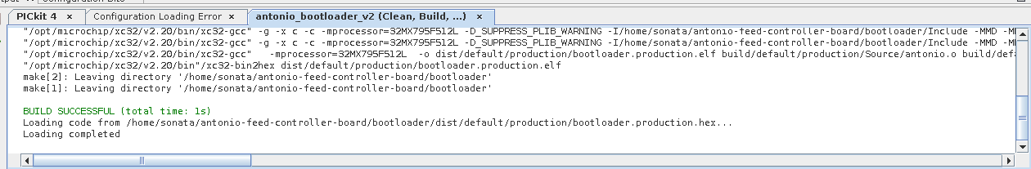

# Connecting JTAG

Make sure you have proper JTAG and that it’s connected to the USB port. After opening the enclosure, localize the microcontroller board and JTAG pins.

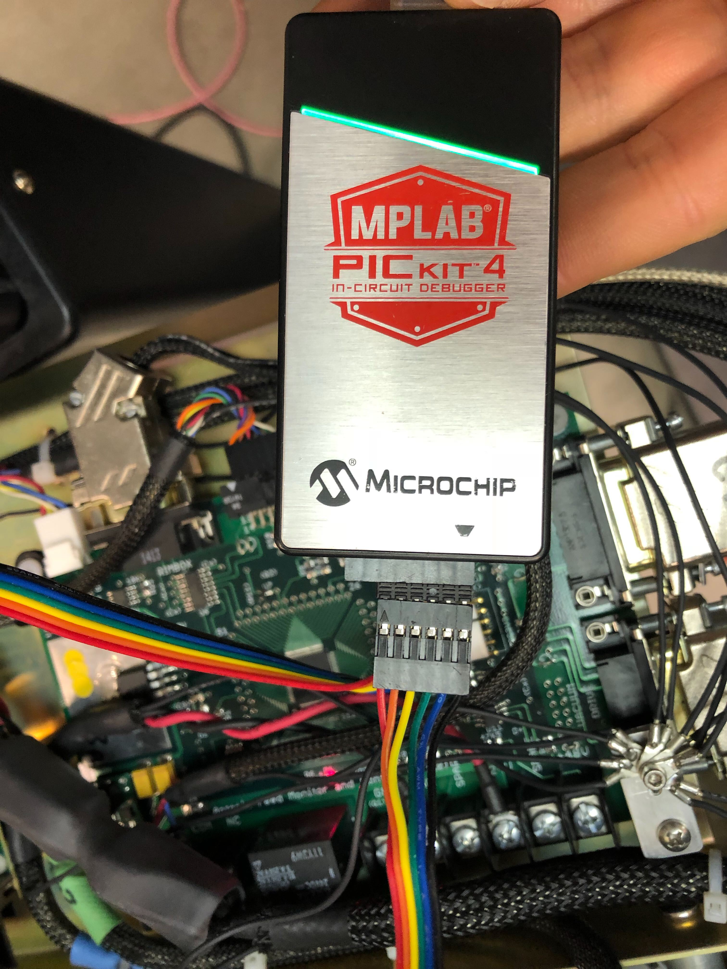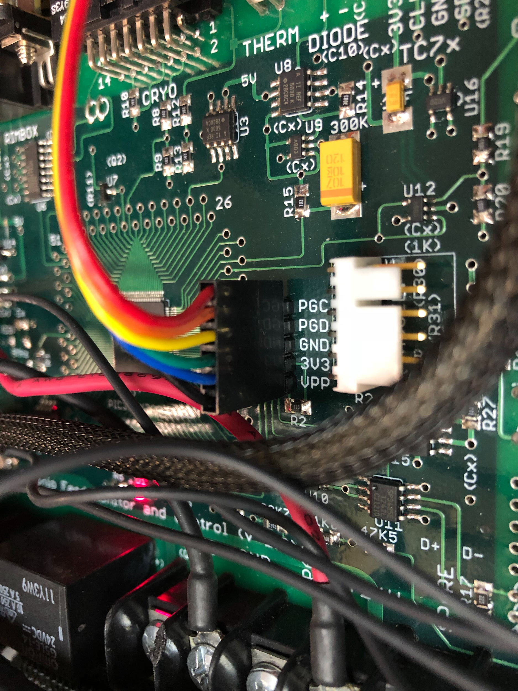

The black cable should be aligned with the vpp pin. Red cable is slack and not connected (note that conector has 6 sockets, where the board has 5 pins).

Make sure that USB-RS232 converter is also connected to your laptop and to the board.

# Program controller with the bootloader

Make sure that bootloader is chosen as a “main” program (bold name). Then click on “make and program device main project”. After programming, the successful information should be displayed in the bottom, containing line “Programming/Verify complete”

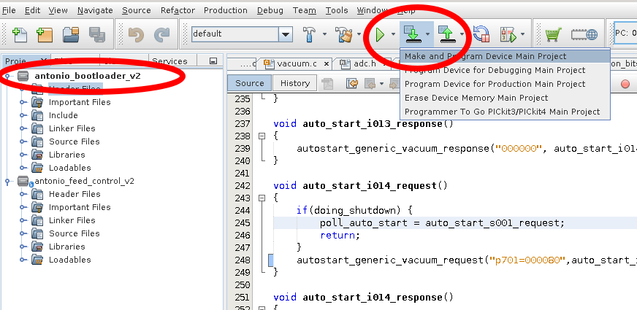

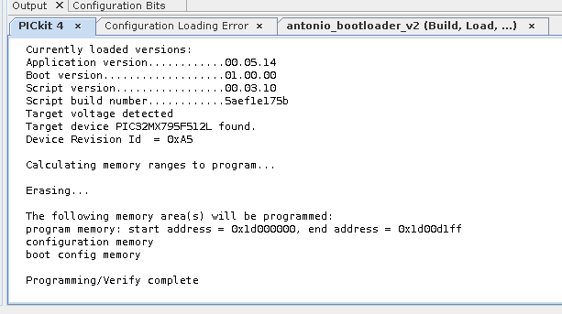

Upload the image

With the bootloader in memory and RS232 connected, make sure that /dev/ttyUSBX is visible in the system. You may start uploading the image. Go to main project directory and call “feed-sd-update.py” python program, pointing to COM port and fs image, e.g.

|  |
| --- |
| ./feed-sd-update.py /dev/ttyUSB0 ./filesystem/antoniofsimage |

The bootloader should reset and slowly accept the image. It may take 10-20 minutes to finish. At the end, you should see the communicat: "feed control board SD update successful - press any key to exit"

# Program controller with the control firmware

Make sure that feed control is chosen as a “main” program (bold name). Then click on “make and program device main project”. After programming, the successful information should be displayed in the bottom, containing the line “Programming/Verify complete”. Before programming starts, you may get a pop-up asking if you want to switch PiCkit to that project.

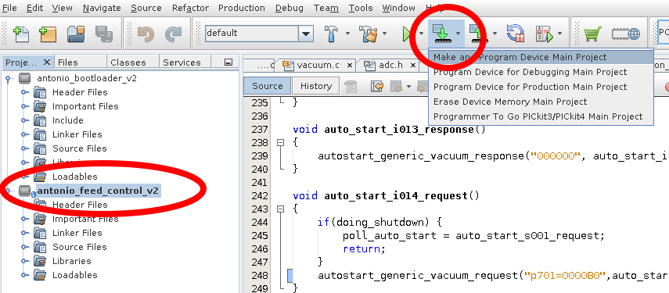

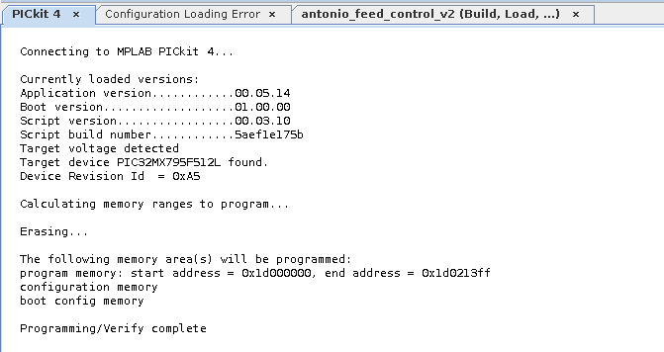

# Verify firmware

Open either minicom or the ./feed_test.py program. Type “getversion” and “man state”. The output should look similar to the picture below. If confirmed, feed is properly programmed. You may want to check “getfeedstartmode”.

